e-Pledge Guide for IU Campaign Volunteers

Andar e-Pledge is the online donation system for the IU United Way campaign. Through e-Pledge, IU employees can donate via payroll deduction, bill me, check, or credit/debit card. Campaign volunteers can access campaign information and campaign reports on the e-Pledge site.

All online pledging is live, campaign reports will be updated immediately. Paper pledges may take a few days to appear in reports, due to the time delay caused by manual entry into the database.

LOGGING IN

Campaign volunteer resources are available on www.unitedway.indiana.edu by scrolling down to the bottom and clicking “CAMPAIGN LEADER RESOURCES.” On this page, the red “Access e-Pledge” button will take you to the e-Pledge system. You will not instruct IU employees to access e-Pledge this way. More information is included later in the guide. You can also access e-Pledge through this link.

You will be prompted to log in using your IU credentials through the SSO Duo Login system. If you are already logged into another IU site in your browser, it may connect you to e-Pledge without asking you to log in.

When you log out of e-Pledge, close your browser. If you’d like to log back in shortly after logging out, you must close your browser, return to www.unitedway.indiana.edu, and click “Access e-Pledge” again.

SWITCHING ROLES

When campaign volunteers log in to e-Pledge, the default page will be the coordinator page. This will show campaign information and reports. Campaign volunteers must switch roles to make their own donation.

Scroll down to the bottom, and on the left side of the page footer, click on “Employee Donor.” This will change your role to an employee donor where you can make your pledge.

When logged into e-Pledge as an employee donor, scroll down to the bottom, and on the left side of the page footer, click on “e-Pledge Coordinator” or “e-Pledge Administrator” (what appears will depend on your role) to return to the system where you can access campaign data and reports.

You do not need to log out to switch roles.

Note the yellow-circled role switcher options in the footer below:

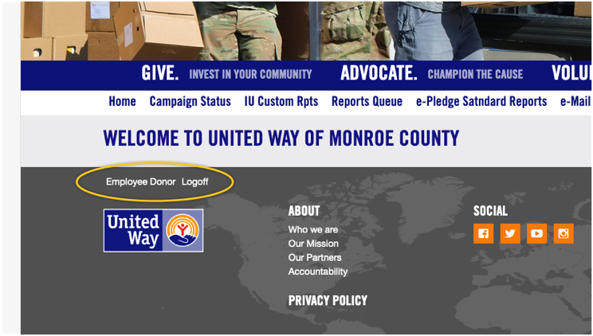

The coordinators’ menu

Home
The Home screen has limited information about United Way. Do not return to the Home page after logging out.

Campaign Status
On this page, you will first see a thermometer showing the campaign progress to the goal. Below the thermometer is a condensed report of the campaign progress. By default, it will show you the “Rollup Amount” report, which is a total report including Indiana University, IU Foundation, and IU Retirees. “All Locations” will show three lines showing the individual progress for IU, IU Foundation, and IU Retirees.

IU Custom Rpts
This menu contains the many campaign reports you can choose from to get information about the ongoing campaign. More information about these reports is found in the “reporting” section of this guide.

Reports Queue
This page is where you can access reports once there are finished being processed. More information about this is also found in the “reporting” section of this guide.

e-Mail Employees
This feature is what volunteers can use to email IU employees within their department or team. More information about this is found in the “emailing employees” section of this guide.

Logoff
You will be logged out of e-Pledge when you click this. To log back in, you must close your browser, return to www.unitedway.indiana.edu, and click “Access e-Pledge.”

Reporting

The e-Pledge reports are where you can get information about the progress of the campaign. There 6 kinds of reports. You may not need to reference all reports; you can use whatever is helpful to you and your campaign.

The types of reports are as follows:

IU Campaign Detail by team and dept: An overall report that breaks down campaign donations by type of donation. Can only be run for all departments.

IU Daily Status Report: A report that shows daily summaries of campaign data, including total donors, total donations, and a breakdown of levels of Vanguard Donors. Can be filtered by team or department.

IU No-Response Report: A report of all employees that have not donated. Can be filtered by team or department.

IU Responsive Donors: A report of all employees that have donated and when they donated. Can be filtered by team or department.

IU Summary I Report: A report that compares current donation totals and participation percentage to the previous year's campaign. Cannot be filtered by department.

IU Team & Dept Report: An overall campaign report that shows number of donors, total donations, and progress to goal. Can be filtered by team or department.

RUNNING A REPORT

To run a report, select the report you’d like to run, scroll down, and click the “Submit” button. For all reports EXCEPT the IU Campaign Detail by team & dept and Summary I Report, you will be taken to a second screen to select a team or department. To do this, you must click the drop-down arrow next to “Select.” Keep in mind, some reports, such as the IU No-Response Report, can produce a report several hundred pages long if you do not filter by team or department!

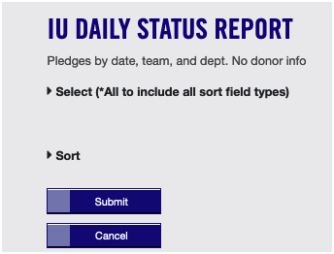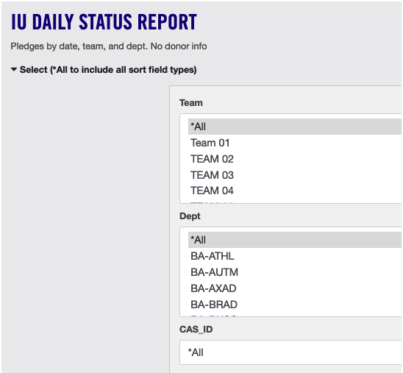
Once you make your selection and click “Submit” again, the screen will reload and you should see a message in red indicated that the report was run successfully.

All reports will be run as CSV files. Your reports can be accessed on the IU CUSTOM RPTS page at the bottom of the page, under “Outputs” or on the REPORTS QUEUE page.

If your report creates a large file, it may take longer to run. If it is still running, the “Status” column will say “Writing” and the link to the report will not be clickable. Refresh the page to check the report’s status. Once the report is ready, the “Status” column will say “Ready,” and the report link will be a blue clickable link. Click on it to download the CSV file.

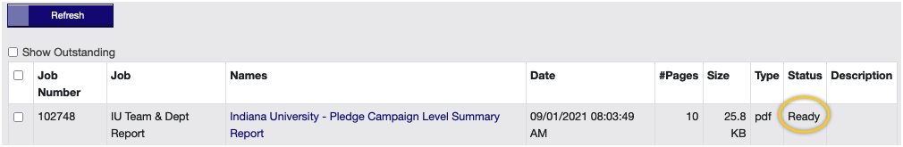

EMAILING EMPLOYEES

Below is the top half of the page used to email employees:

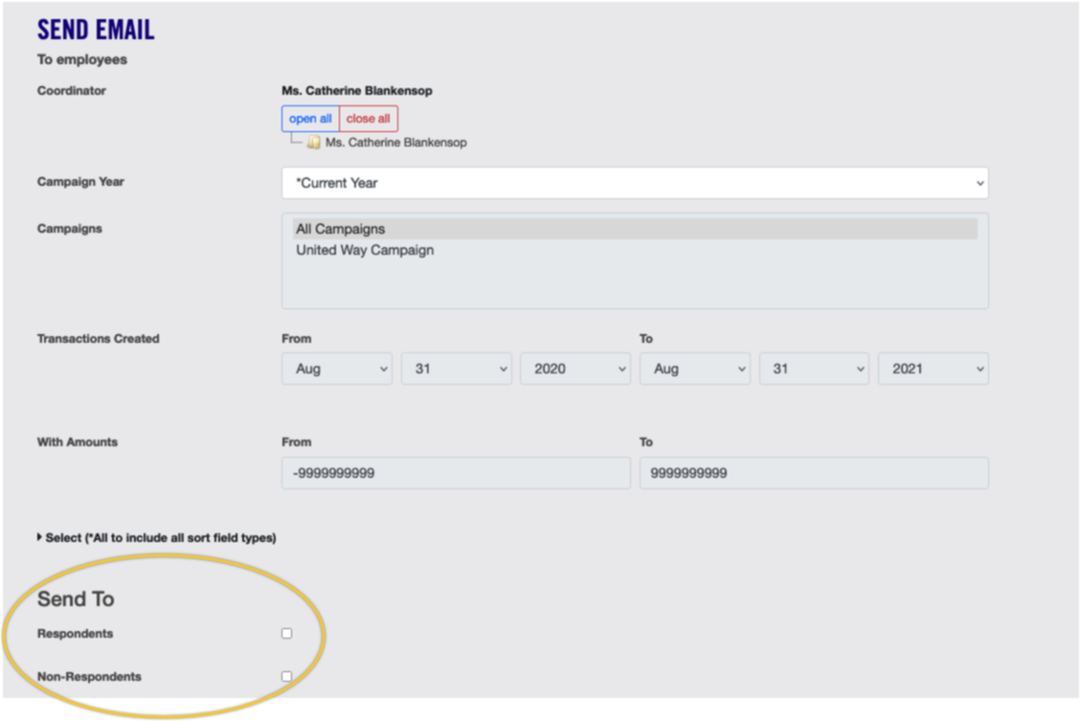

Counter-intuitively, the first step in composing an emailing is to choose whether it will be sent to “Respondents” or “Non-Respondents” under the “Send To” header (as circled above). This is what the systems refers to those who have donated and those who have not donated this year.

*Without first specifying this, other fields will be locked and unable to be changed.*

Campaign Year
It is recommended to leave this as “Current Year.” If you were interested in emailing donors from past years, you could change this field. This will not be an available function until next year because we are using this system for the first time.

Campaign
For this field, be sure to change the default “All Campaigns” to “United Way Campaign.”

Transactions Created
This field allows you to contact specific groups of donors. For example, if you chose “Respondents” and limited the date range to the past week, your email would be sent to all employees who have donated in the past week. If it does not need to be restricted, the time period including this year’s campaign is March 1, 2022 to February 28, 2023.

With Amounts
This field allows you to contact donors based on the amount they donated. You do not need to change it if you are emailing all donors regardless of amount. As an example, this field might be utilized when thanking Vanguard Donors.

Select:
The most important field, it allows you to select teams or departments whose employees should receive the email. You must click the arrow to the left of “select” to prompt this selection to drop down.

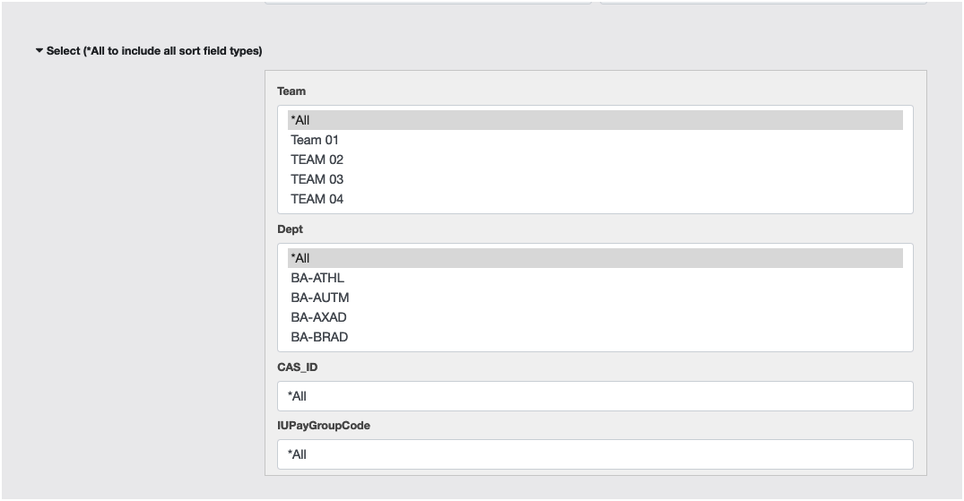

NOTE: Be careful here! If you leave the selection boxes set to default, the system could send your email to all 10,000 IU employees!

Now here’s the second half of the screen – the fun half, where you get to compose the email:

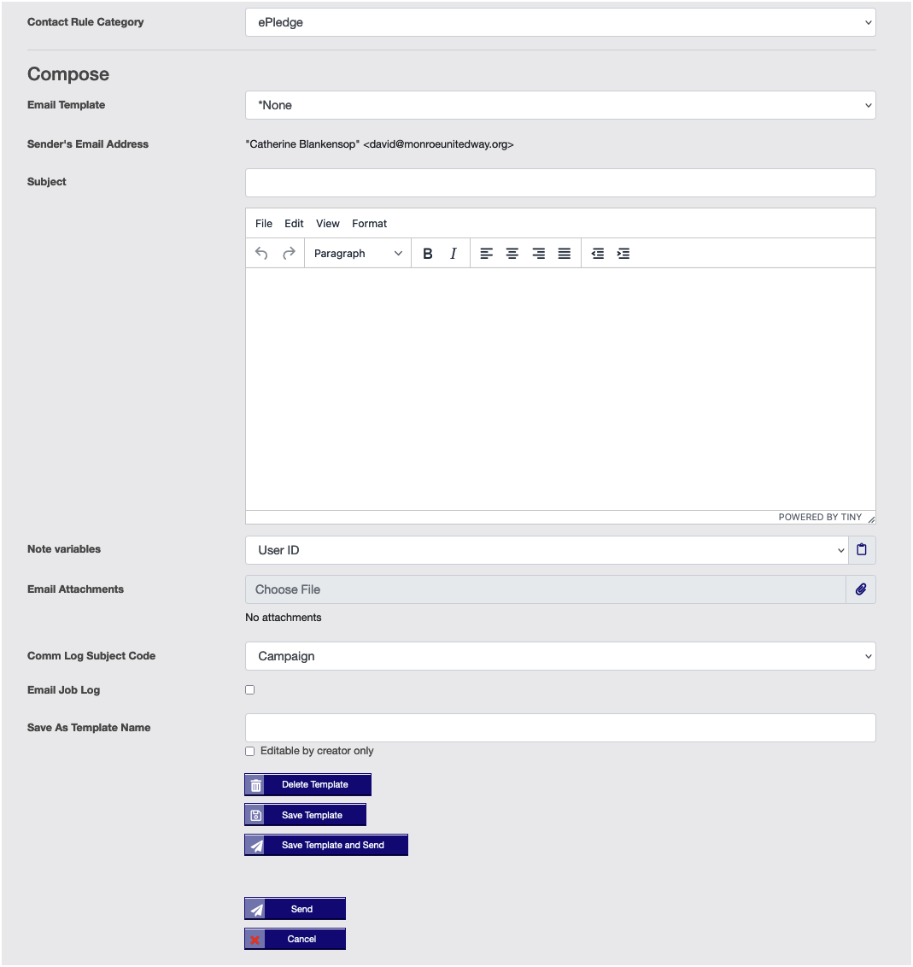
Contact Rule Category
Leave at default “e-Pledge.”

Email Template
You can choose an existing email template from the drop-down. You may also write your own email and save it under a unique template name to be retrieved for later emails.

Sender’s Email Address
You will notice that a coordinator’s name is shown, but the sending address will always be the United Way email, UWMCCampaign@monroeunitedway.org. This is for technical reasons having to do with the way e-Pledge sends emails through United Way of Monroe County. NOTE: As a result of this limitation, please make it clear to your email recipients who you are, and that if they wish to reply to your email, they will need to start a new email addressed to your email address.

Note Variables
These are system variables – such as <firstname>, <IU Team>, etc -- that can be inserted in your email. For example, inserting <firstname> would auto-fill the first name of each recipient. Choose a note variable from the dropdown and click on the clipboard to insert that variable in the text of the email at the cursor insertion point.

Attachments
For security reasons, the ability to attach files has been turned off.

Comm Log Subject Code
You can leave this at default or choose a code from the drop-down. The code becomes associated with your email in the system communications log.

Email Job Log
If you check this box, the log information will be sent to the sender. This may mean the information will go to David Cook rather than you. This feature still needs to be tested.

e-PLEDGE FOR DONORS

LOGGING IN

Donors should be directed to www.unitedway.indiana.edu. They should navigate to the How to Give page, which can be accessed by the Navigation bar at the top, or by the “Donate Now” button near the top of the homepage. Once on this page, they can read about the different ways to donate. They should scroll down and click the red “Donate now through e-Pledge!” button to log into e-Pledge.

They will be prompted to log in using the IU credentials or will be automatically logged in if they are already logged in to an IU site on their browser.

WHAT DONORS SEE

E-News Subscribe
This menu item sends a request to UWMC to be added to the subscription list for the monthly eNews newsletter.

My history
Shows your account history

My interests
This is a place to select areas of interest such as financial stability or seniors. One of the interests is volunteering, which tells UWMC that you might be interested in volunteering.

My profile
Shows basic information about your donor account.

When they click on Pledge Now, they see the first page of the pledging menu:

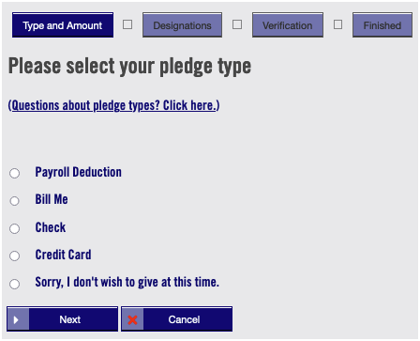

A couple of points of note:
- Though few retirees have IU login access anymore, if a retiree does login and reach this pledge menu, they won’t see the Payroll Deduction pledging type.

- Please note that there is a no-pledge option; this allows someone to pledge no-pledge (rather than a zero-pledge) so that we can see their intent.

Once a pledge type is chosen, and the donor clicks Next, they see the screen for their particular pledge type.

For each one of these pledge types, donors will be able to fill in the following after entering their donation amount.

In memoriam
Name of deceased person

In honor of
Name of person being honored

Contact info
The contact is the person you wish to have notified of your in memoriam or in honor of gift. Name and address would be good. Name and email OK

Affiliation
This does not need filled in, as all donors are affiliated with IU.

Combine all my gifts
This is if someone wants their donation combined and recorded with another individual, such as a spouse. The individual combined with can donate through IU, through any other organization, or independently. If the individual does not work at IU, please include as much information about them as possible.

The different ways to donates are explained below:

Payroll Deduction Pledges
This screen is fairly self-explanatory. Note that the number of pay periods is taken from the employee’s record in the e-Pledge system. If it is incorrect for some reason, they can override it, but only from within a restricted list of choices.

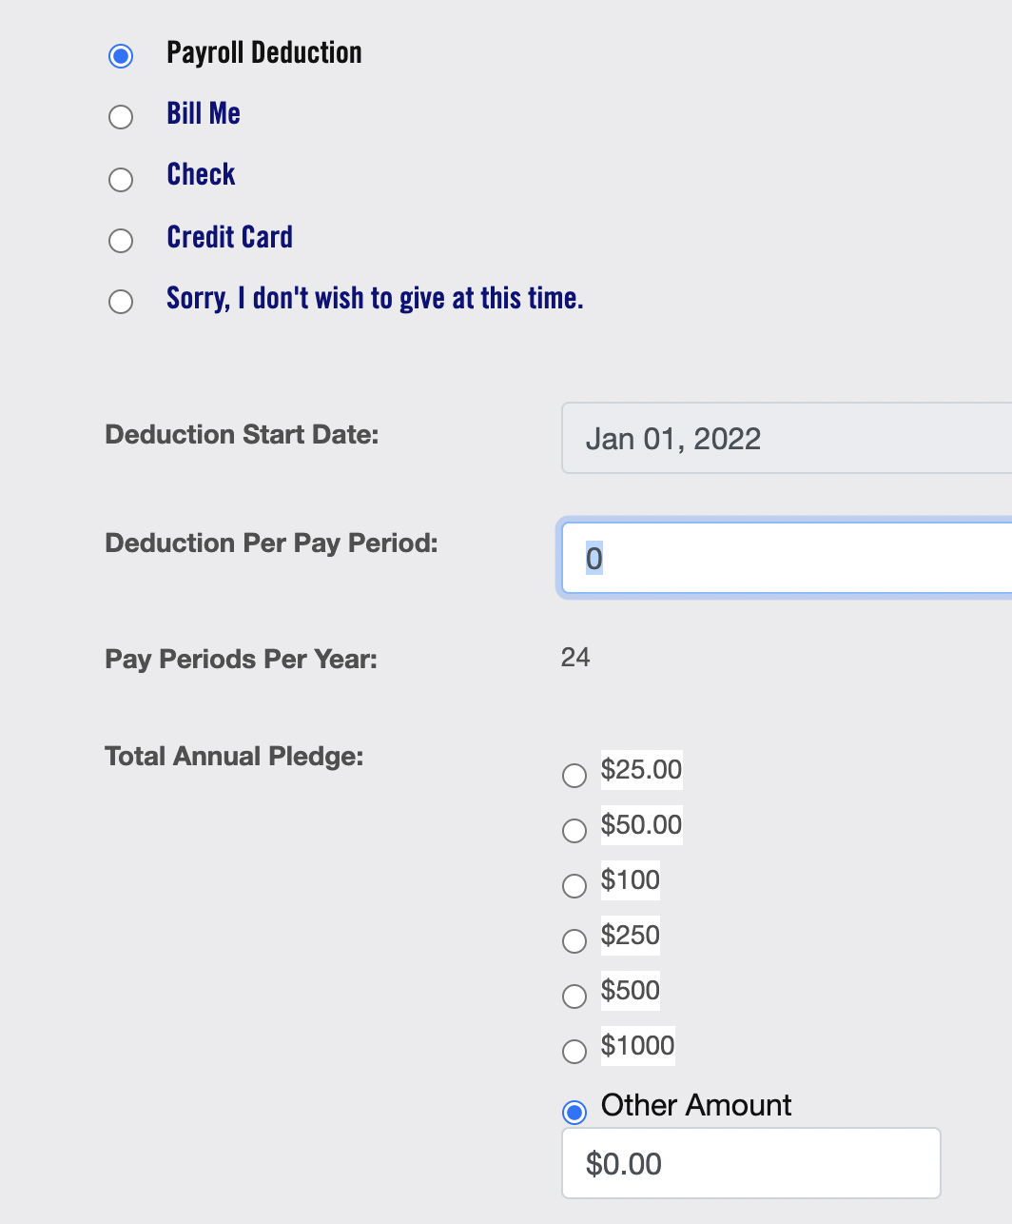

Once the total pledge amount is not zero, there will be a new option displayed above the Next and Cancel buttons:

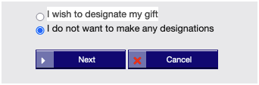

The designation process will be covered in a separate section below, after the descriptions of each pledge type.

Bill-Me Pledges
Bill-me pledges allow the donor to pledge a certain annual amount to be paid to United Way of Monroe County in equal installments. The payment arrangement is between the donor and UWMC; it does not go through IU’s payroll department.

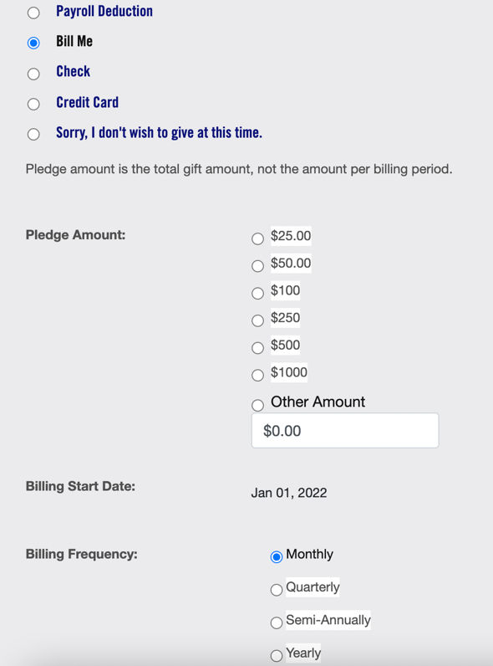

As with payroll deductions, the Bill-Me pledge type allows designations.

Pledge by Personal Check
A donor who wishes to give by check can fill out an online pledge before mailing their check to United Way of Monroe County.

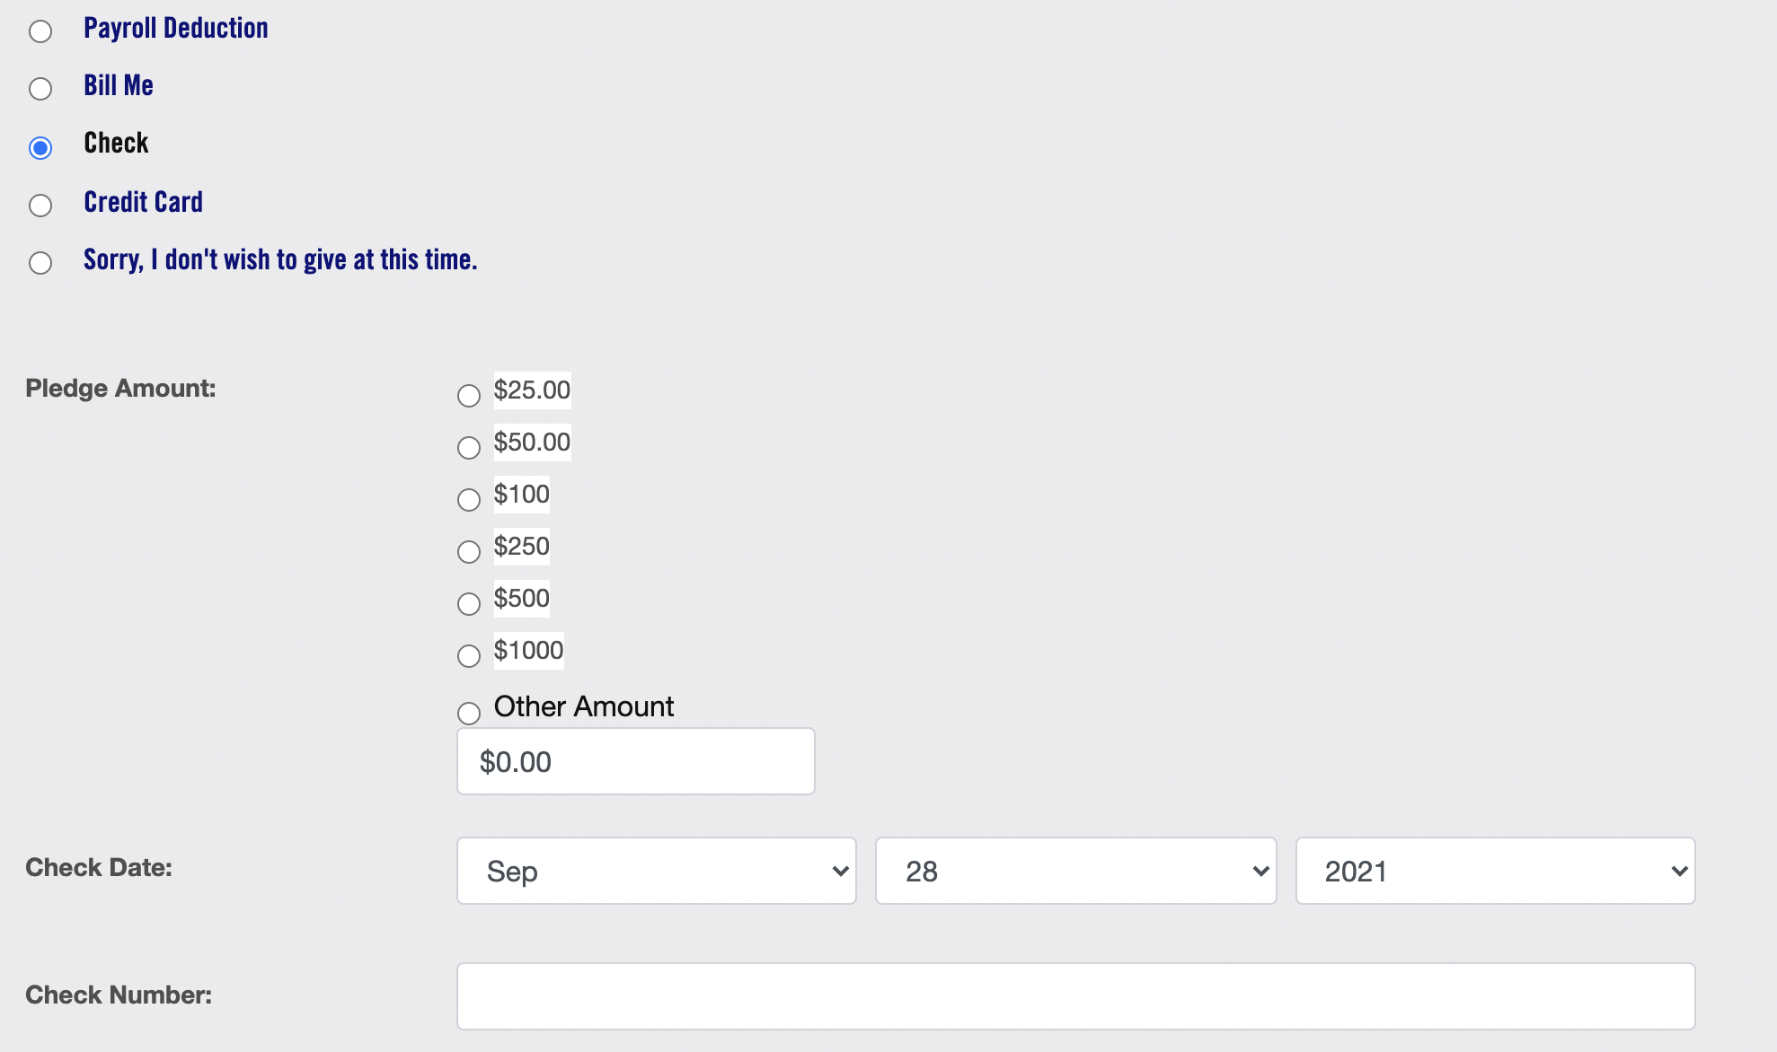
Donating with check also allows designations.
Credit Card Pledges
These pledges are handled by our secure web processor CyberSource. NOTE: there is no longer a $5 minimum for credit/debit donations.

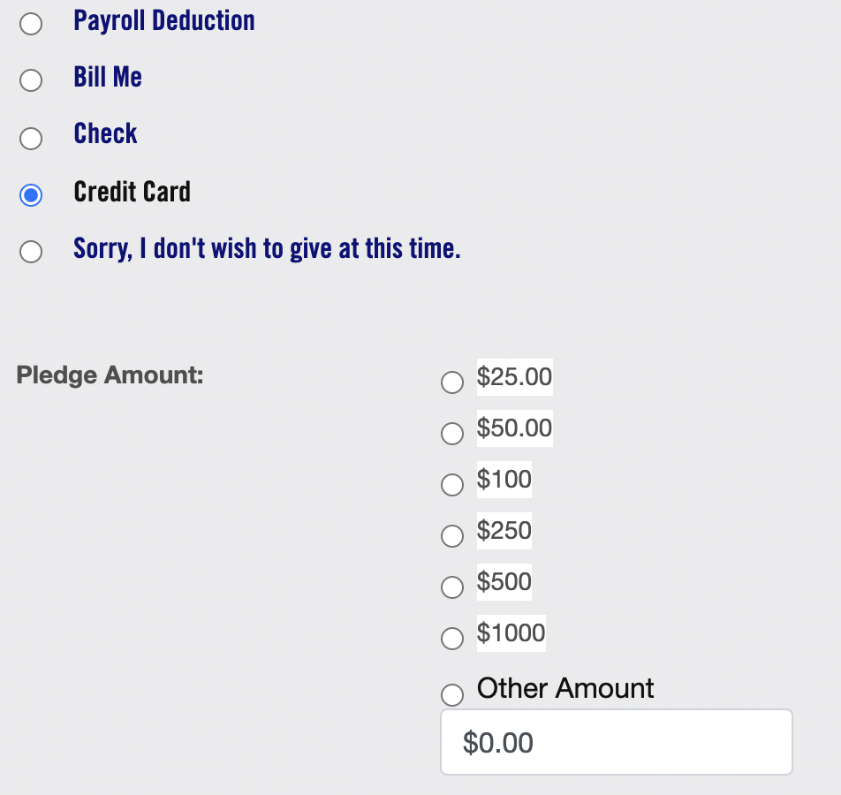

A couple of notes:
- Credit card giving allows the donor to set up a recurring gift; if they click the checkbox under recurring gift, then they see an additional set of prompts:

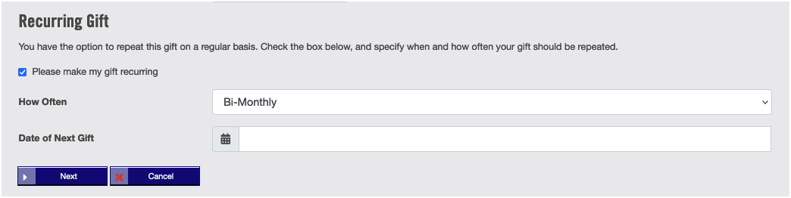

Choices for How often are Bimonthly, Monthly, Quarterly, Semi-Annually, Annually.

NOTE: A recurring pledge is auto-renewing until the donor contacts UWMC to cancel or change it.

No Pledge (Sorry, I don’t wish to give at this time)

This option is for those who do not wish to give for this campaign and would like this decision to be recorded by United Way of Monroe County. If the donor chooses this option, they are taken to an abbreviated version of the Verification page, which acknowledges their decision:

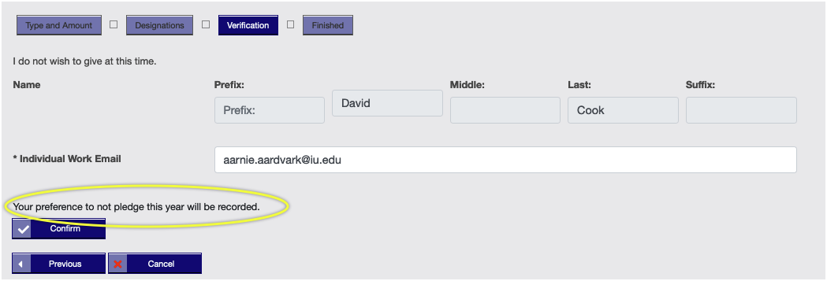

For no-pledge to be recorded, they should click Confirm.
Clicking Cancel does not record the no-pledge decision; instead, it records nothing at all.

ENTERING DESIGNATIONS

The default for donations to UWMC is that funds go into our Community Action Fund. However, donors are able to earmark all or part of their donation to one or more external 501©3 non-profits.

There are three ways to identify designees in e-Pledge’s designations section, and they are non-exclusive; that is, they can use one or more of the ways.

Member agencies
The donor is shown a list of UWMC’s 24 member agencies (such as Amethyst House or Stone Belt) and can choose which ones to designate and how much money to give, subject to the $25 minimum per designation.

The Agency portion of the designations screen looks like this:

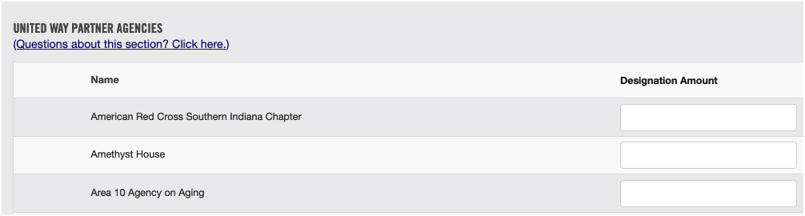

Agency search
Below the agency list is a search box. Using this, the donor can locate local area agencies in addition to our member agencies. For an example, on the following screen grab, I search for “symp”:

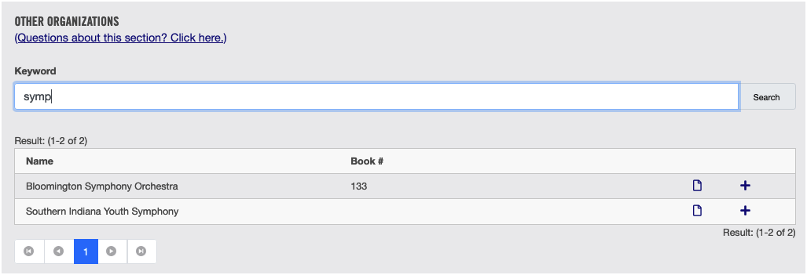

Clicking the + sign next to any of the listings that are retrieved promotes that agency into another list directly above, which allows the donor to choose an amount to designate to that organization. For the example, I’ve chosen the Bloomington Symphony and decided to direct $100 to them. Here’s what that looks like:

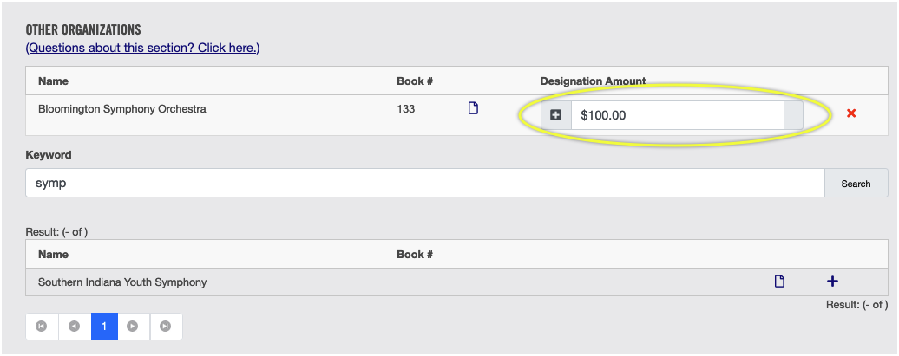

Write-In Designations
If the donor can’t find the organization, they want using the above two methods, the write-in section will handle anything. Other than the $25 minimum pledge, it is not picky.

This means that it is up to the donor to be sure they’re designating to a 501©3 non-profit; e-Pledge has no way of verifying this. In addition, if the donor writes in an organization that is not well-known and/or not local, it’s important that they include enough information in their write-in to help us locate the organization. Here’s what the screen looks like for a single write-in designation:

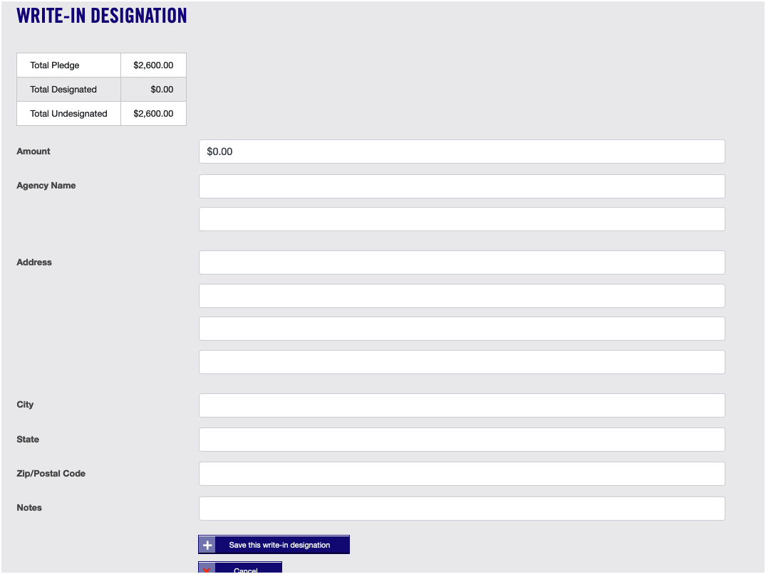

Notice that there are two lines of agency name info and 4 lines of street address, so the donor should be able to be specific about who and where the organization is.

NOTE: If we at UWMC are unable to locate the organization or we determine that it is not a 501©3, we will try to contact the donor to discuss alternatives. If we can’t contact them, the designation will not be processed, and the amount of the designation will be directed to the Community Action Fund.

THE VERIFICATION PAGE

Having finished their pledge, the donor sees the Pledge Verification page, which is a partial summary of their pledge information plus some additional information not collected previously in the pledge.

The fields on this page include:

Name Lines 1 & 2
These are the lines that would appear in a Vanguard roster listing. They don’t show up for donors below the Vanguard level.

Name and email
These will be auto generated. Double-check them to ensure they are correct. Please note: if you change your email in this field, it will change your email in the e-Pledge system. It is recommended that it is left as your IU email.

Check boxes in the middle of the screen
- Do not contact me – not the same as “anonymous.” It means don’t call, email, or mail
- Send me an email confirmation – send confirmation of this pledge
- Young Leaders – the donor is a young leader as per UW definition

Loyal contributor
The year the donor became a loyal contributor to United Way. Once this is entered, it will be remembered for future donations.

WHAT DONORS SEE – THE CONFIRMATION PAGE

This page shows a summary of the donor’s pledge information (though not designation details). To record the pledge, the donor must click Confirm. In this example, notice that I used the in memoriam field, along with the associated contact info field. I also filled in an affiliation with Westinghouse.

